***Name :-*** Shubhi Gupta

Emailid:- gshubhi2604@gmail.com

***Internship Day1-Task-1***:-

Write an email to your office for three days leave.

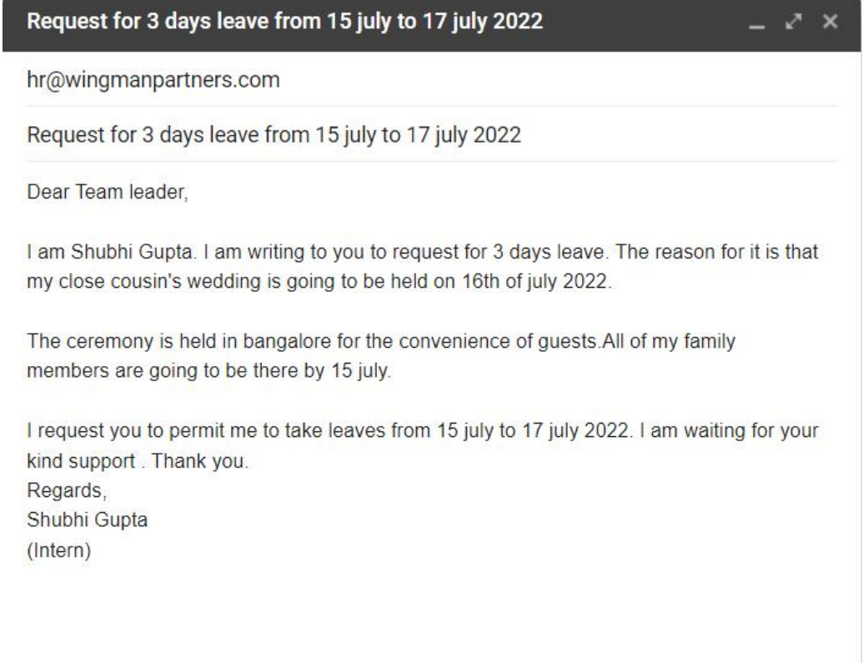

Write an email to the supervisor intimating about the absence.

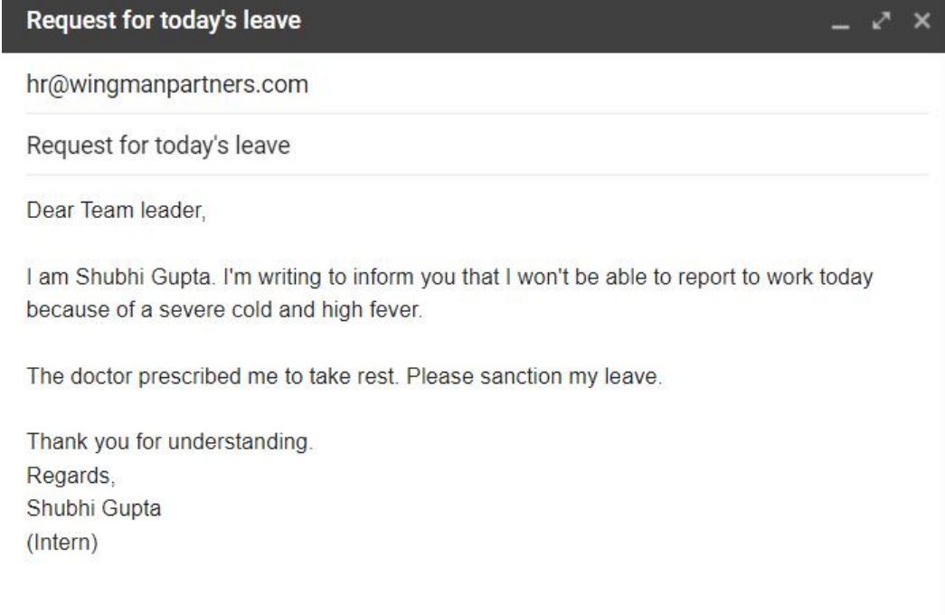

Write an email to express an apology.

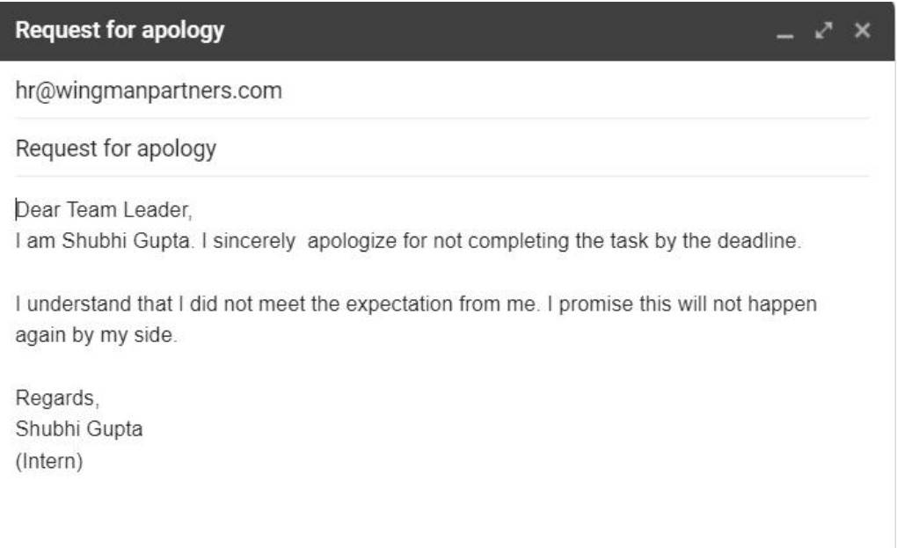

Write an email to your supervisor that you need help to complete the given task.

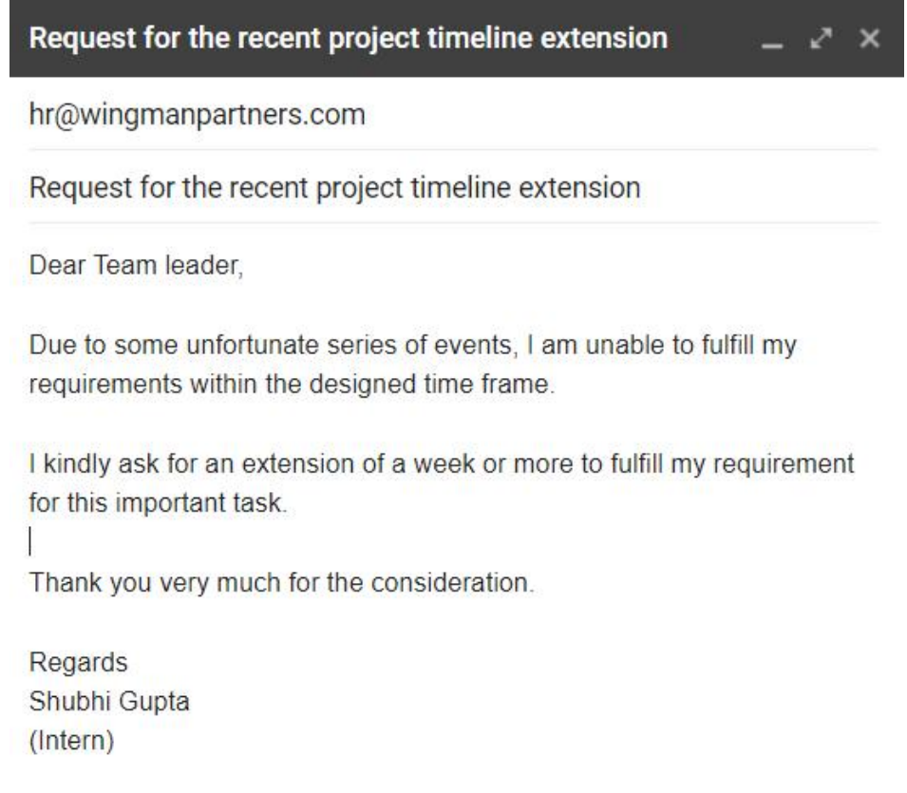

Write an email for the timeline extension.

